**Landing, Login, and Enrollment Pages Development**

Stephanie Loper

The University of Arizona Global Campus

CST 499 Capstone for Computer Software Technology  
Instructor: Joseph Rangitsch

10.14.2024

**How to Run a PHP File in XAMPP**

Running PHP files in XAMPP is essential for local development and surprisingly straightforward. After installing XAMPP, the first thing you do is open the XAMPP Control Panel and start both Apache (the web server that handles PHP) and MySQL (the database server). Without these services running, PHP files and database interactions won’t work.

“In the XAMPP directory, there exists a folder called “htdocs”. This is where all the programs for the web pages will be stored” (Ravikiran, 2024). In this example, I created a folder within htdocs called "StephazonU" and began to build my PHP files inside that folder.

To then view your PHP files in the browser, open your web browser and type localhost/StephazonU/filename.php into the address bar. XAMPP will process the PHP code and display the result, whether it's rendering an HTML page or interacting with your database.

This workflow allows you to test PHP code locally, making it ideal for development before deploying your site to a live server.

**MySQL Database Functions and Creating a Database Connection Class**

When interacting with MySQL databases in PHP, security and efficiency are key, which is where MySQLi functions come into play. These functions allow for secure connections, prepared statements, and error handling. Here's a breakdown of the core functions I used:

* **Establishing a connection**: Connecting to the database involves providing server details (localhost for local development), username, password, and the database name. In this example, the database is hosted locally, meaning the username is by default “root” and the password is empty. This connection is essential for any interaction with the database, like reading or writing data.
* **Prepared statements**: Instead of directly writing SQL queries, I used prepared statements. A “ Prepared Statement object contains not just a SQL statement, but a SQL statement that has been precompiled. This means that when the Prepared Statement is executed, the DBMS can just run the Prepared Statement SQL statement without having to compile it first” (Oracle, 2022). This can also help prevent SQL injection, a common security threat where attackers manipulate queries by inserting malicious code into user inputs.

To simplify the process of connecting to the database across different parts of the project, I created a custom database connection class. This class centralizes all the connection logic, so instead of writing connection code in every PHP script, I can simply include this class and call its methods. The class also handles error reporting and ensures that resources are properly freed up by closing connections after a query is run.

By using this connection class, I can avoid redundant code, reduce the chance of errors, and ensure better maintainability as the project grows.

**Steps for Creating the Registration Page and Storing User Information**

The registration page is the gateway for new users to join Stephazon University. To build it, I followed these basic steps.

1. **Creating the Registration Form**: The registration page includes a form where users input their details, such as first name, last name, email, password, and whether they are a student or faculty member. The form sends this data to the server using the POST method, ensuring that sensitive information like the password isn't exposed in the URL.
2. **Validating the Input**: Once the form is submitted, the first thing the server-side script does is validate the input. This includes checking that all fields are filled in and ensuring the email format is valid. Basic validation on the front end is also a good practice, but server-side validation is critical for security, as users could bypass front-end checks.
3. **Hashing the Password**: For security, storing plain-text passwords in the database is a huge risk. To prevent this, I hashed the password using a secure algorithm.This means that even if someone gains unauthorized access to the database, they won’t be able to see the actual passwords. When users log in, their input password will be compared against the hashed version in the database.
4. **Inserting Data into the Database**: After validation and password hashing, the next step is to insert the user's details into the database. This is done using a prepared statement to safely pass the data to the SQL query. The prepared statement binds the form inputs (like name, email, and hashed password) to the SQL query, ensuring that the query executes securely.
5. **Providing Feedback**: Once the user is registered, the script either redirects them to a login page or displays a success message confirming that their registration was successful. This feedback is important for user experience and ensures they know their information was saved.

In this process, I aimed to create a seamless flow where users can submit their information, have it securely processed, and have their data stored in the database. Future functionalities, like course registration, will rely on this foundational step, as user accounts will be required for personalized access. StephazonU is an extension of my CST310 project, the Stephazon Employee Portal, which originally focused on employee management and internal operations. I am excited to build on that foundation as StephazonU now expands into the educational realm, providing users with interactive learning experiences while continuing the theme of world domination from the original project.

**Screenshots**

**XAMPP Control Panel**

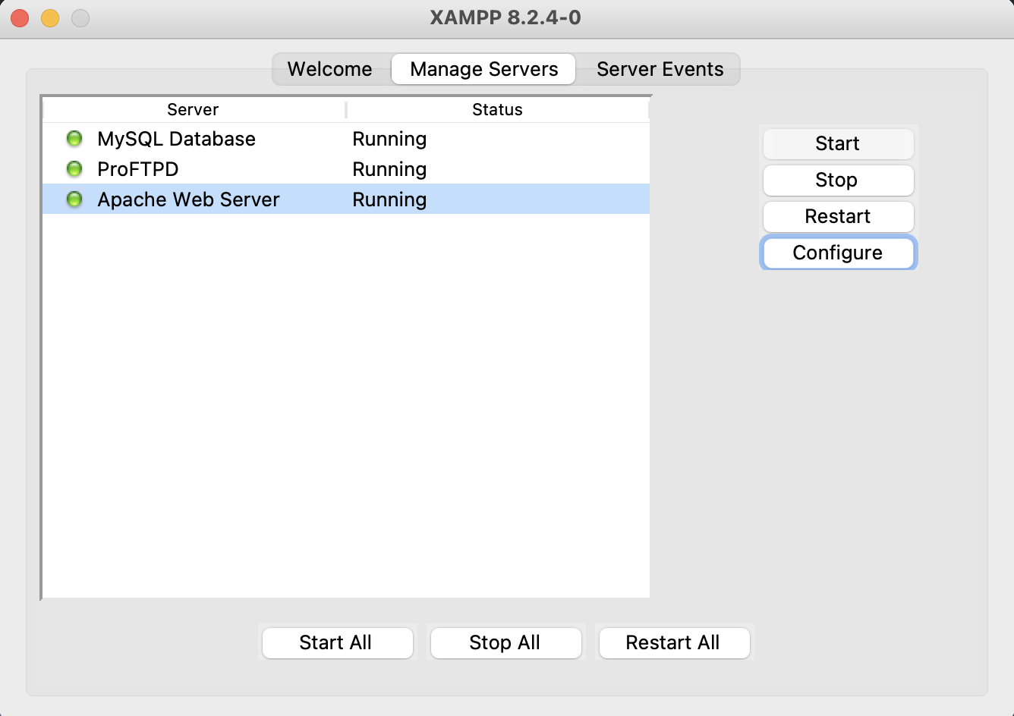

**XAMPP htdocs Folder**

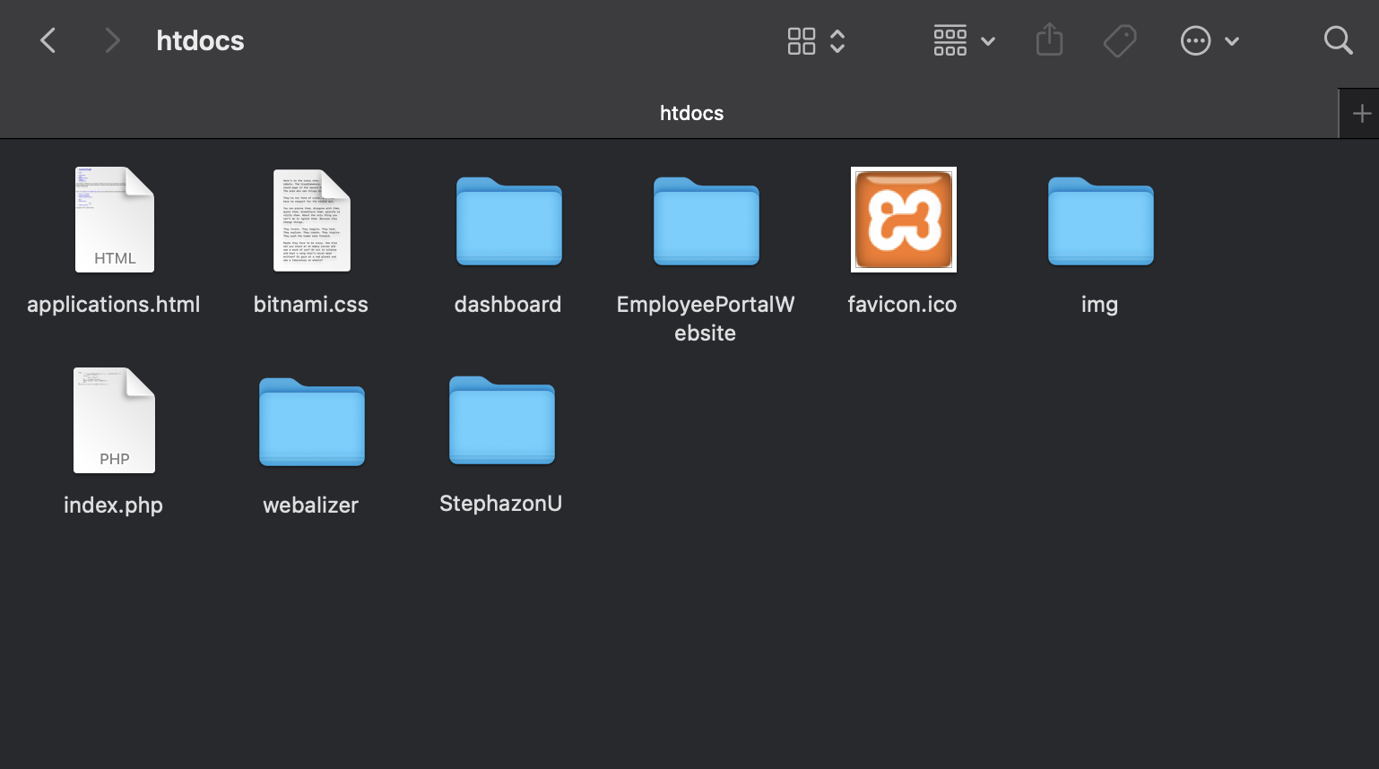

**Browser running localhost/index.php and Landing Page Layout**



**Login Page Layout**

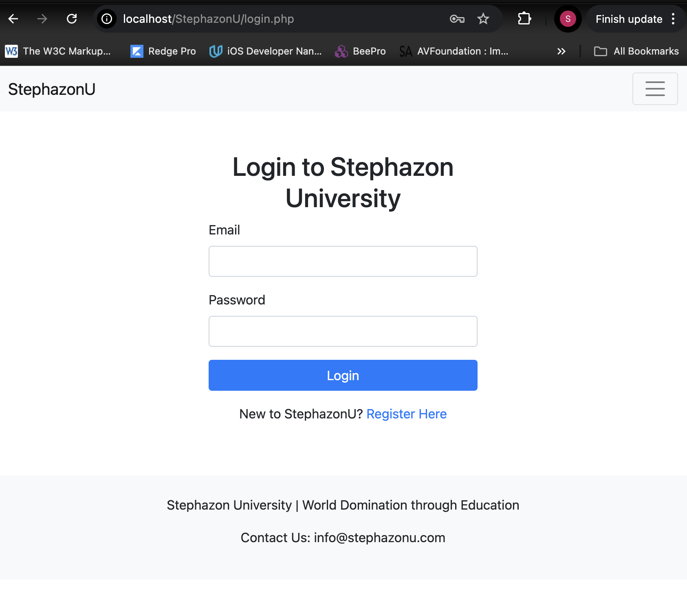

**Registration Page Layout**



**tblUsers Table Structure**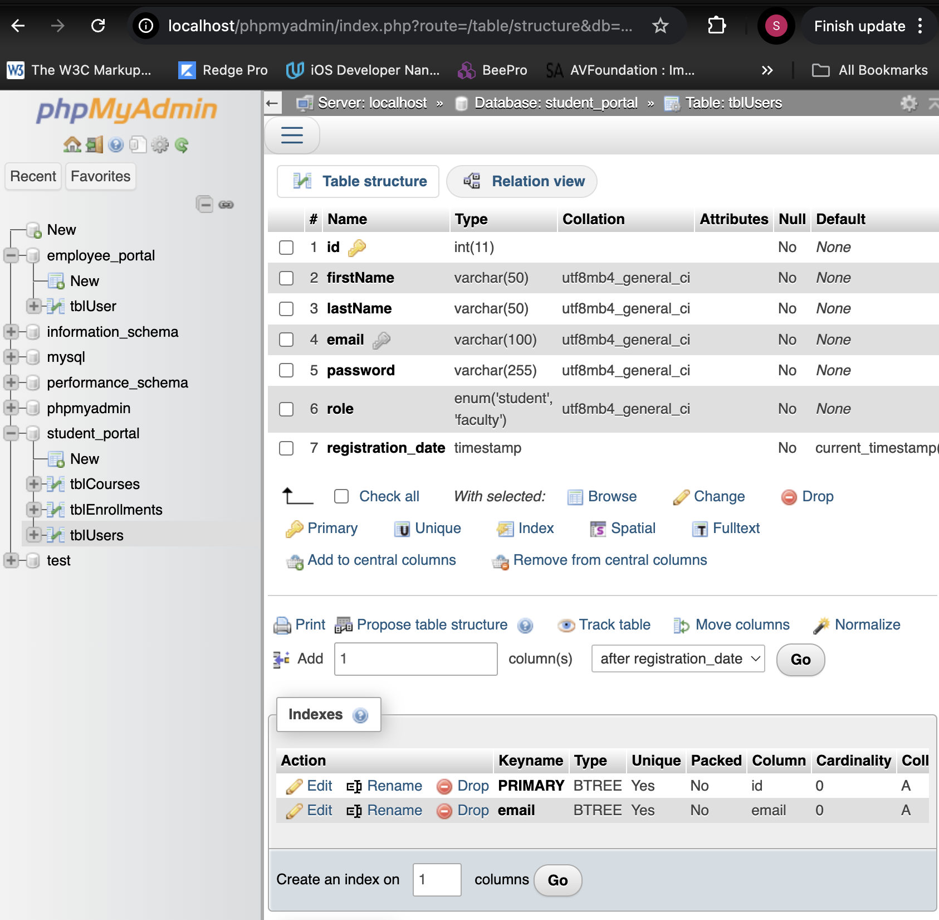

**tblCourses Table Structure**

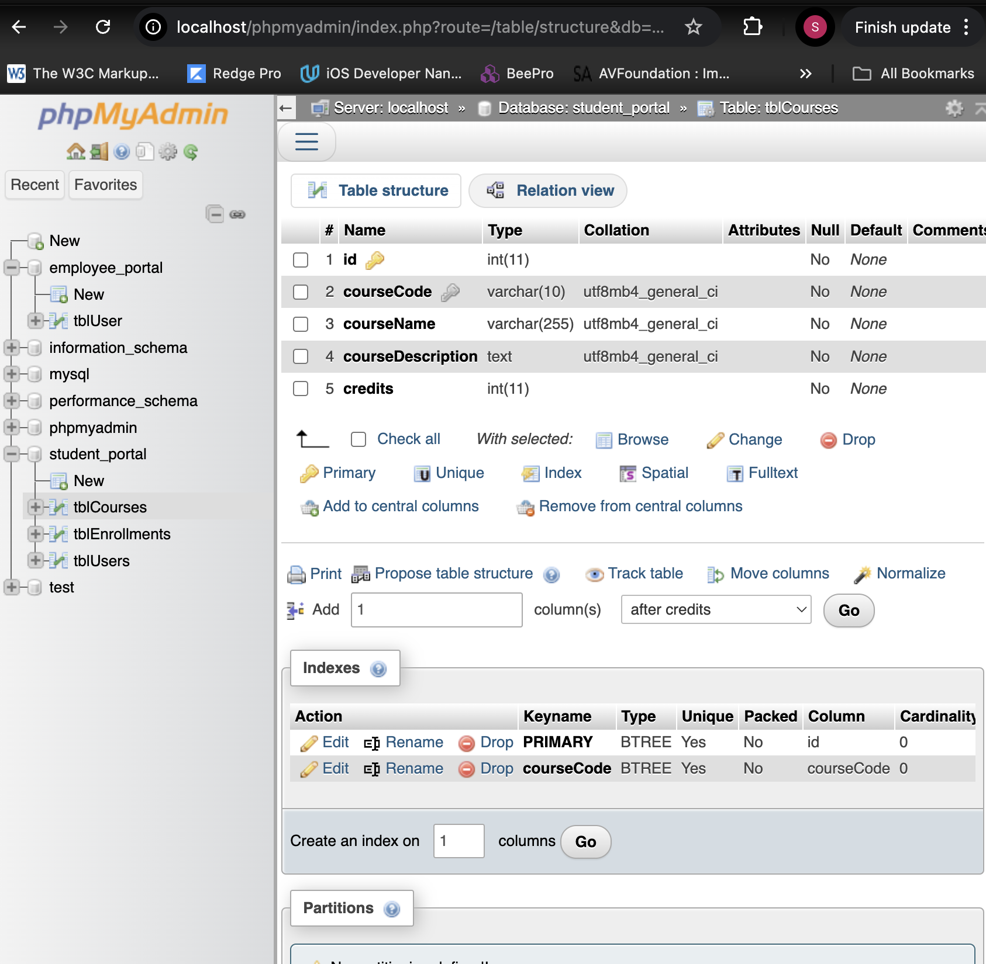

**Database Connection Code (db_connection.php)**

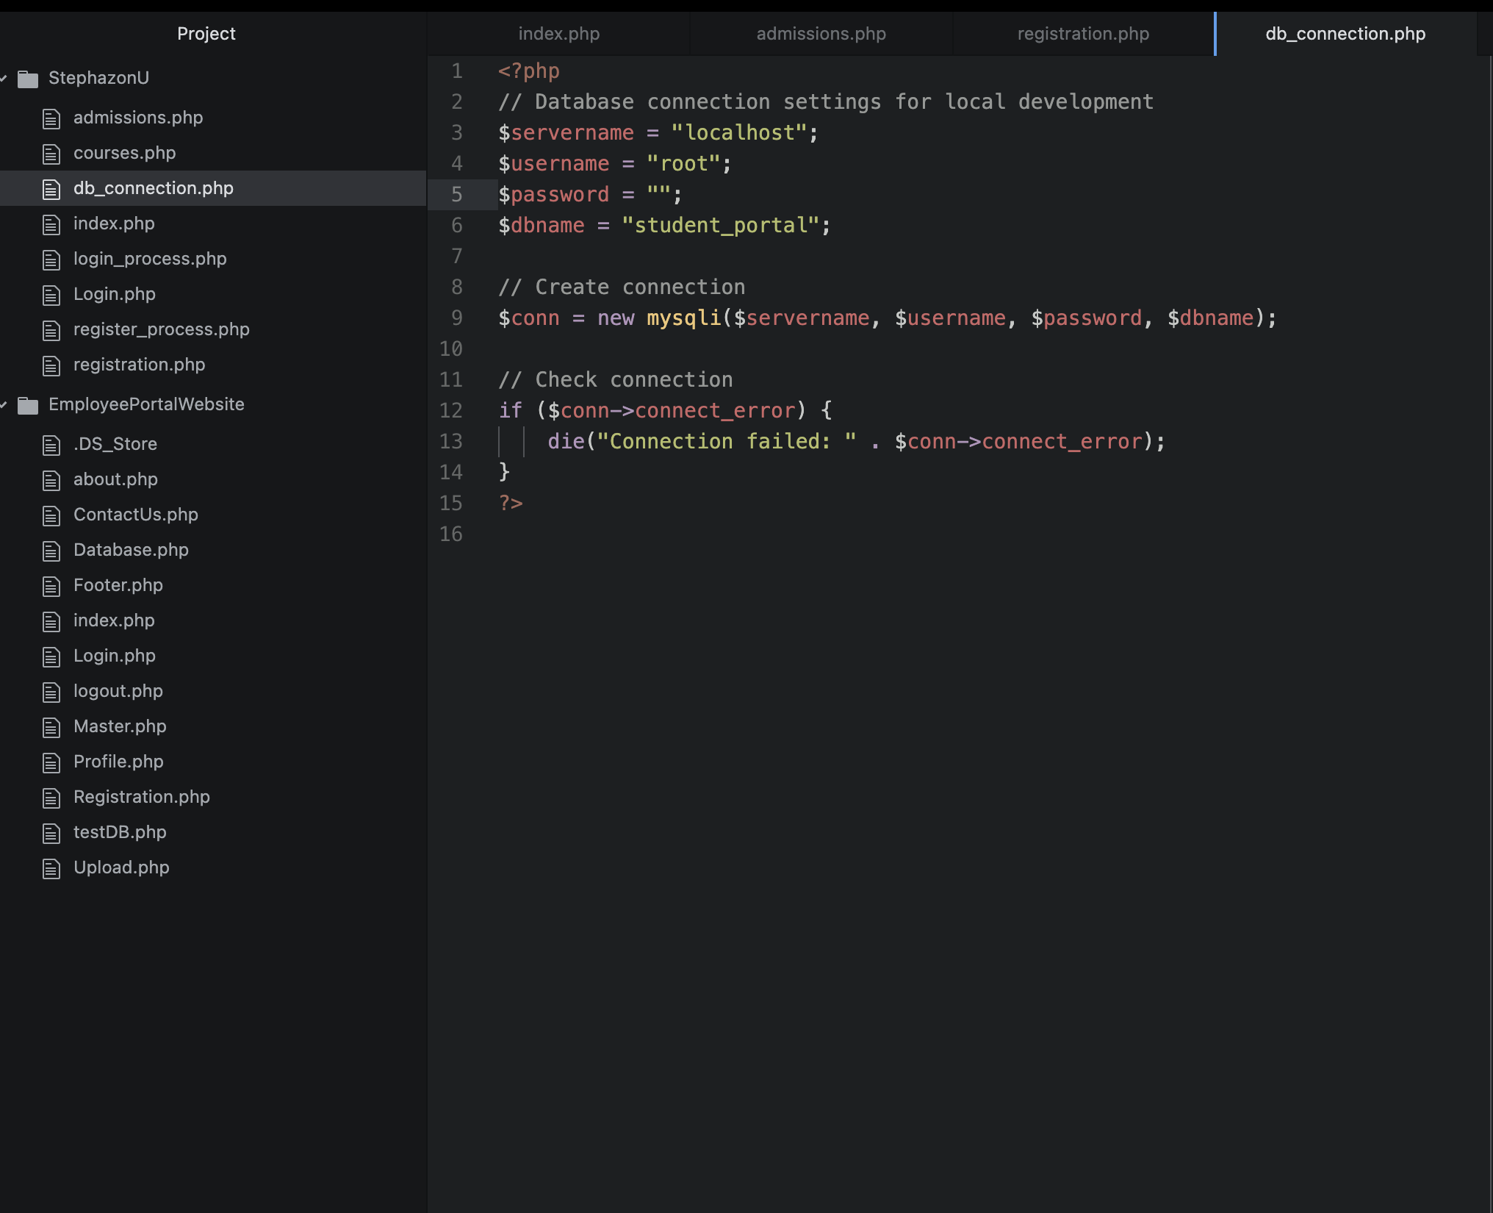

**Prepared Statement Code (register_process.php)**

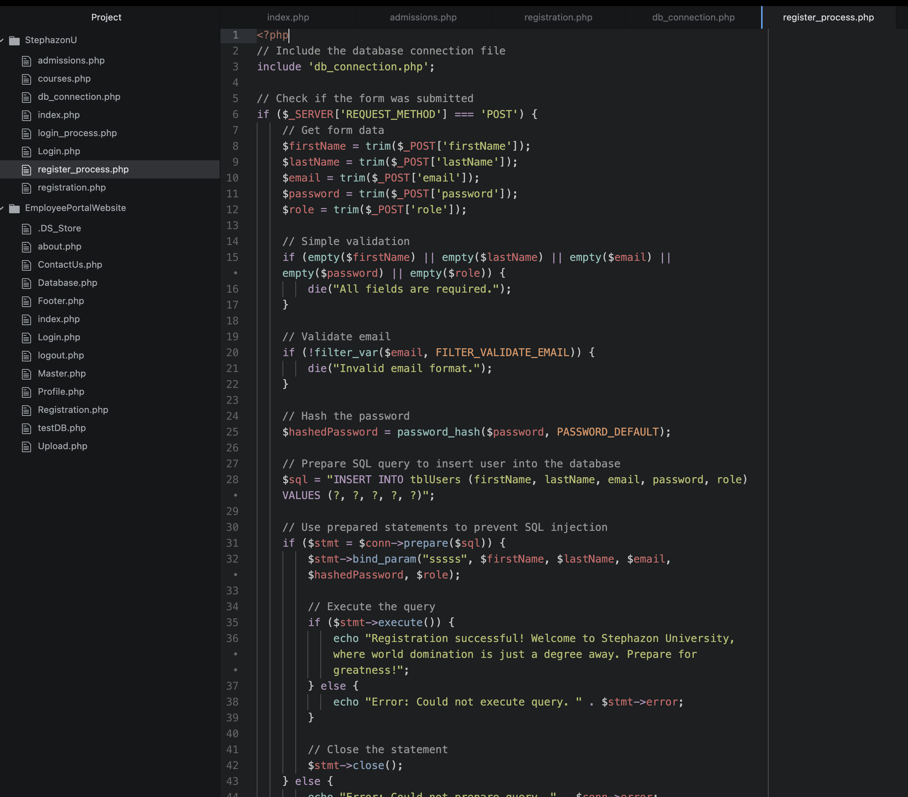

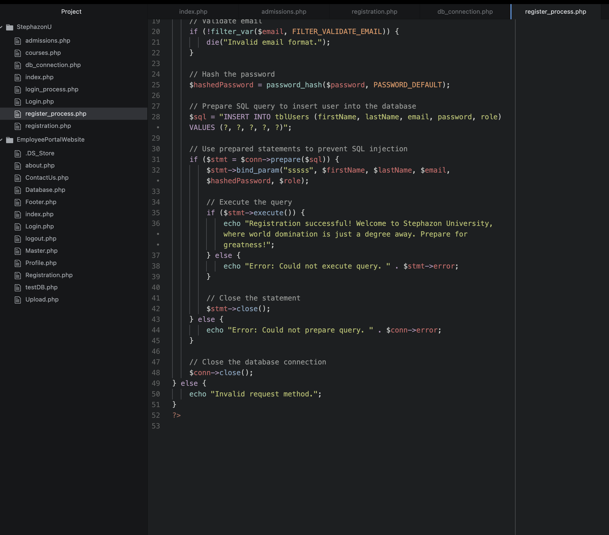

**Registration.PHP Code**

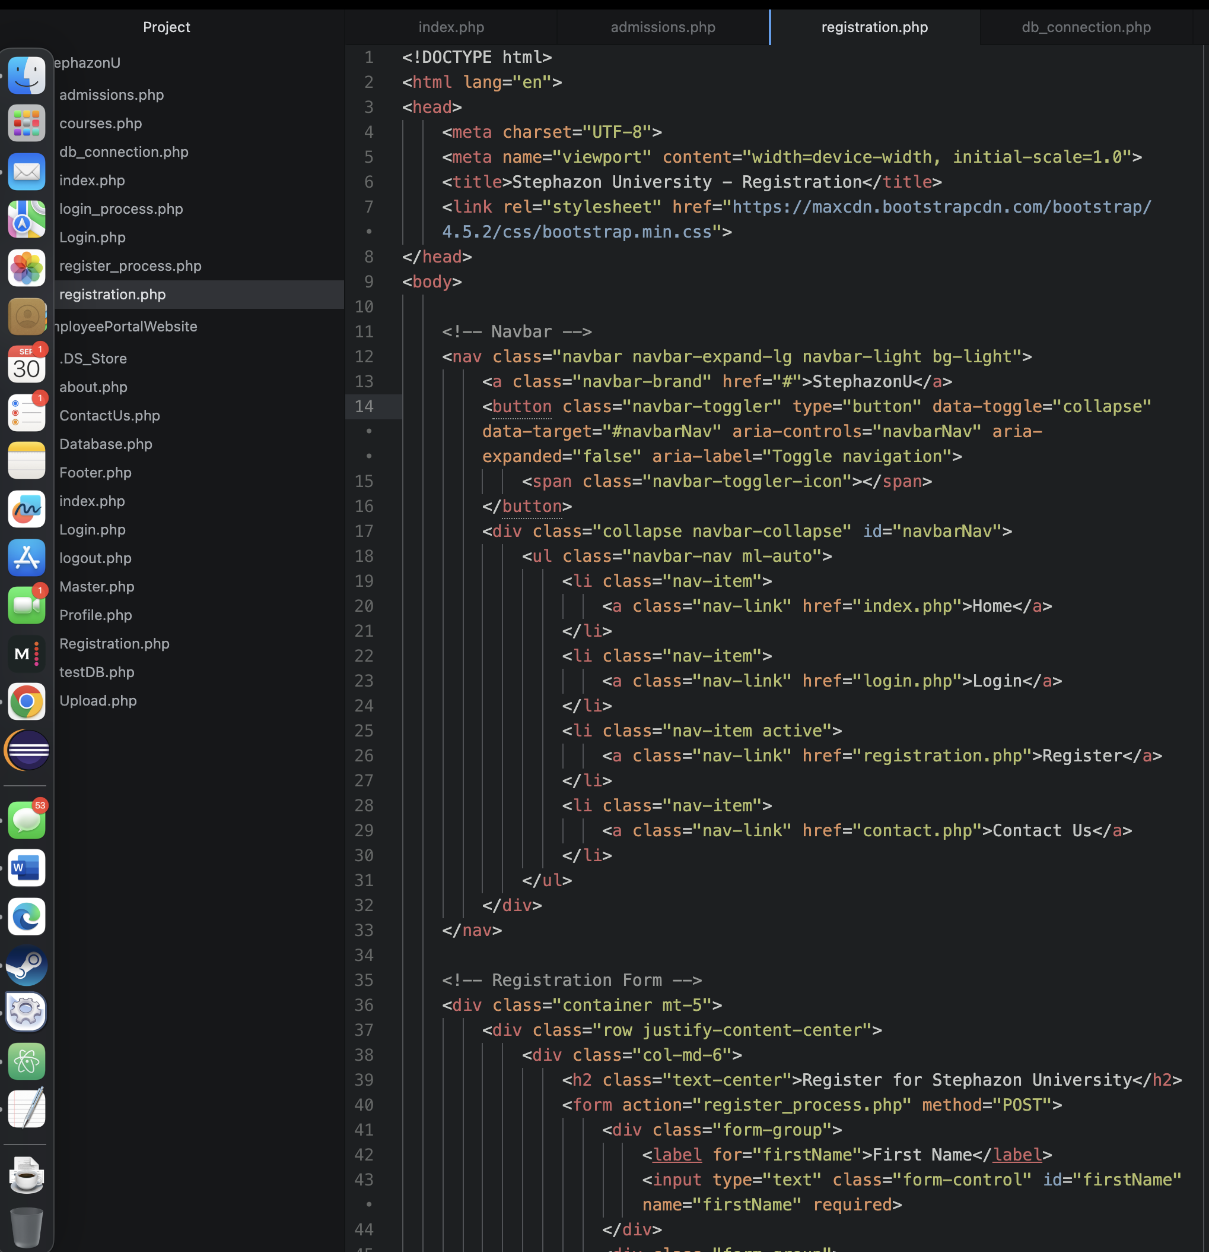

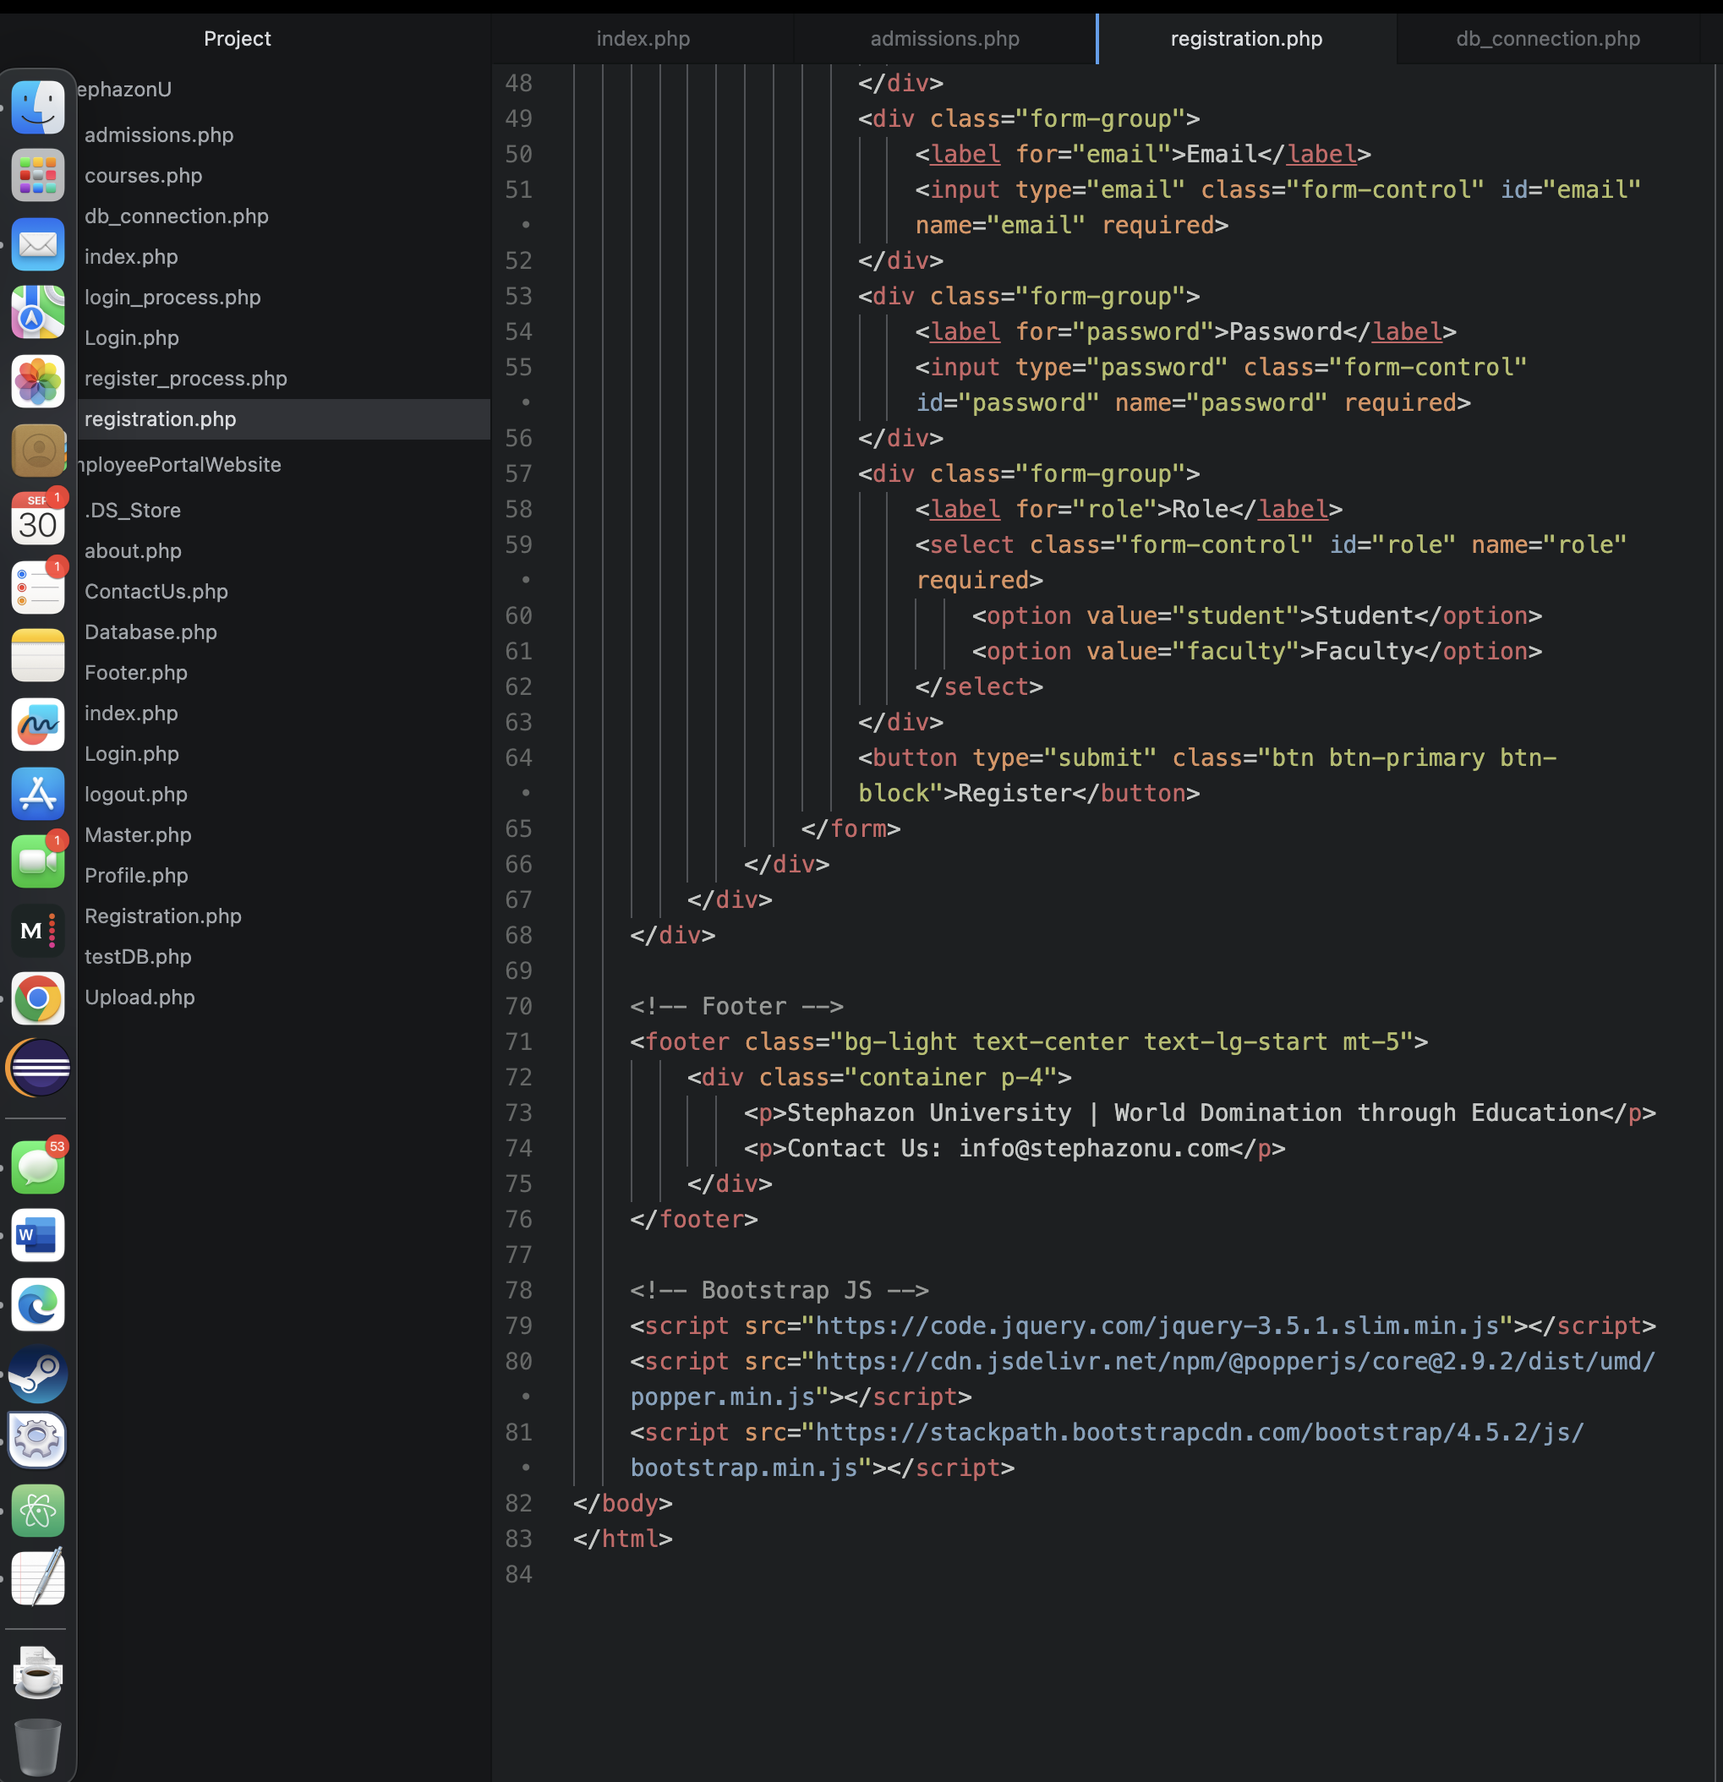

**Index.php**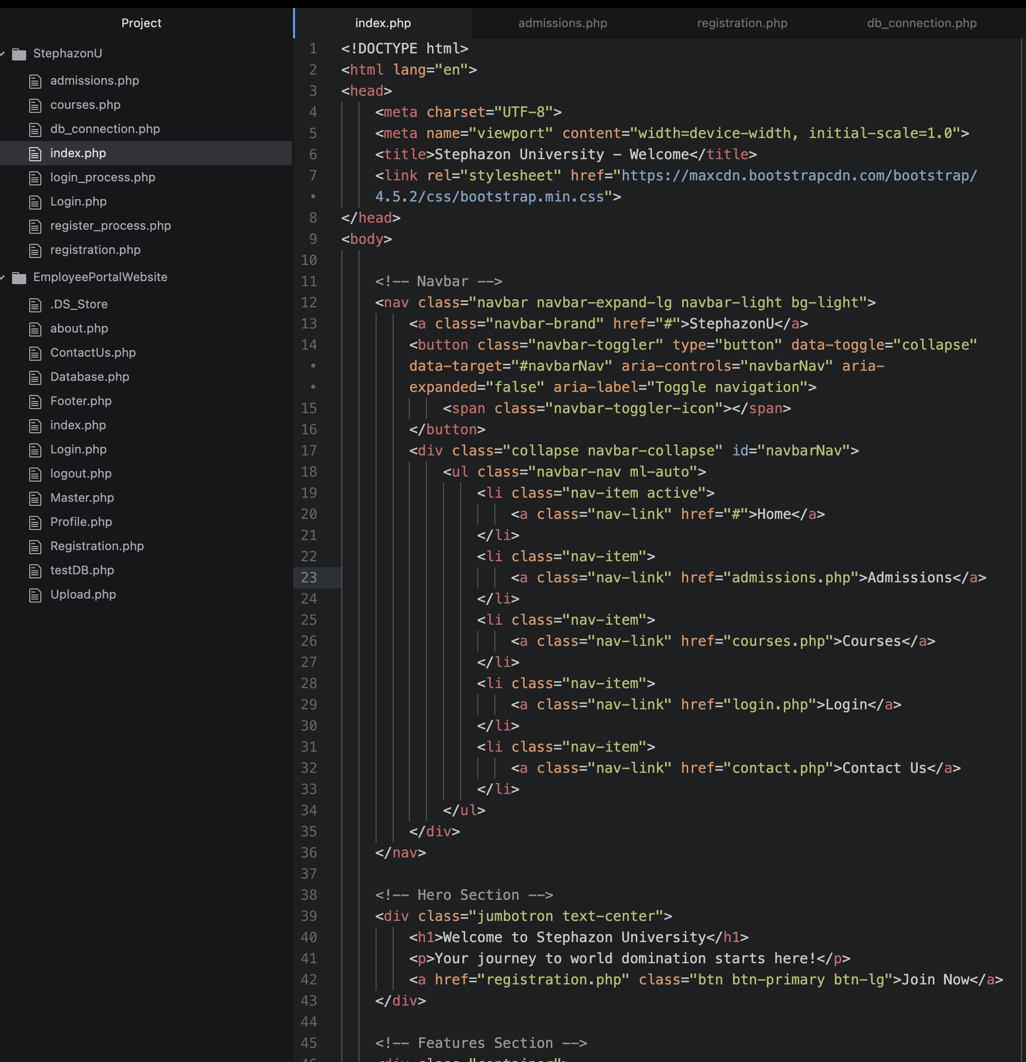

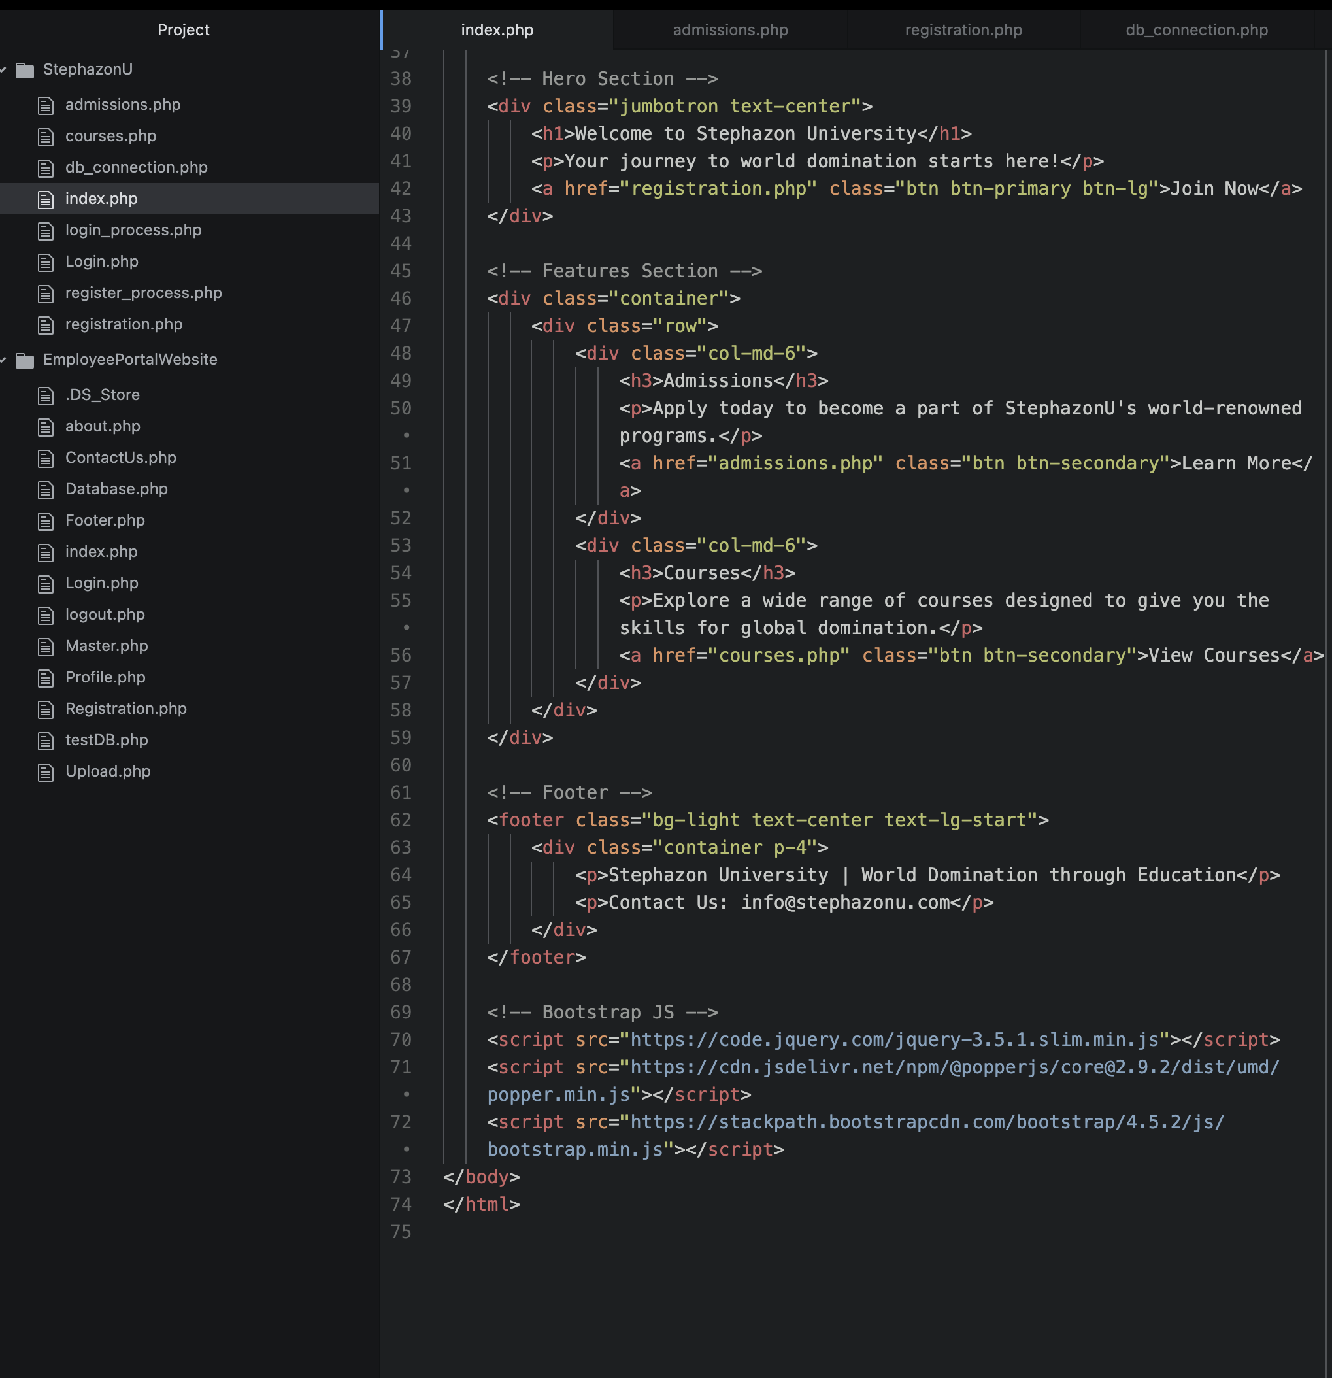

**Login.php**

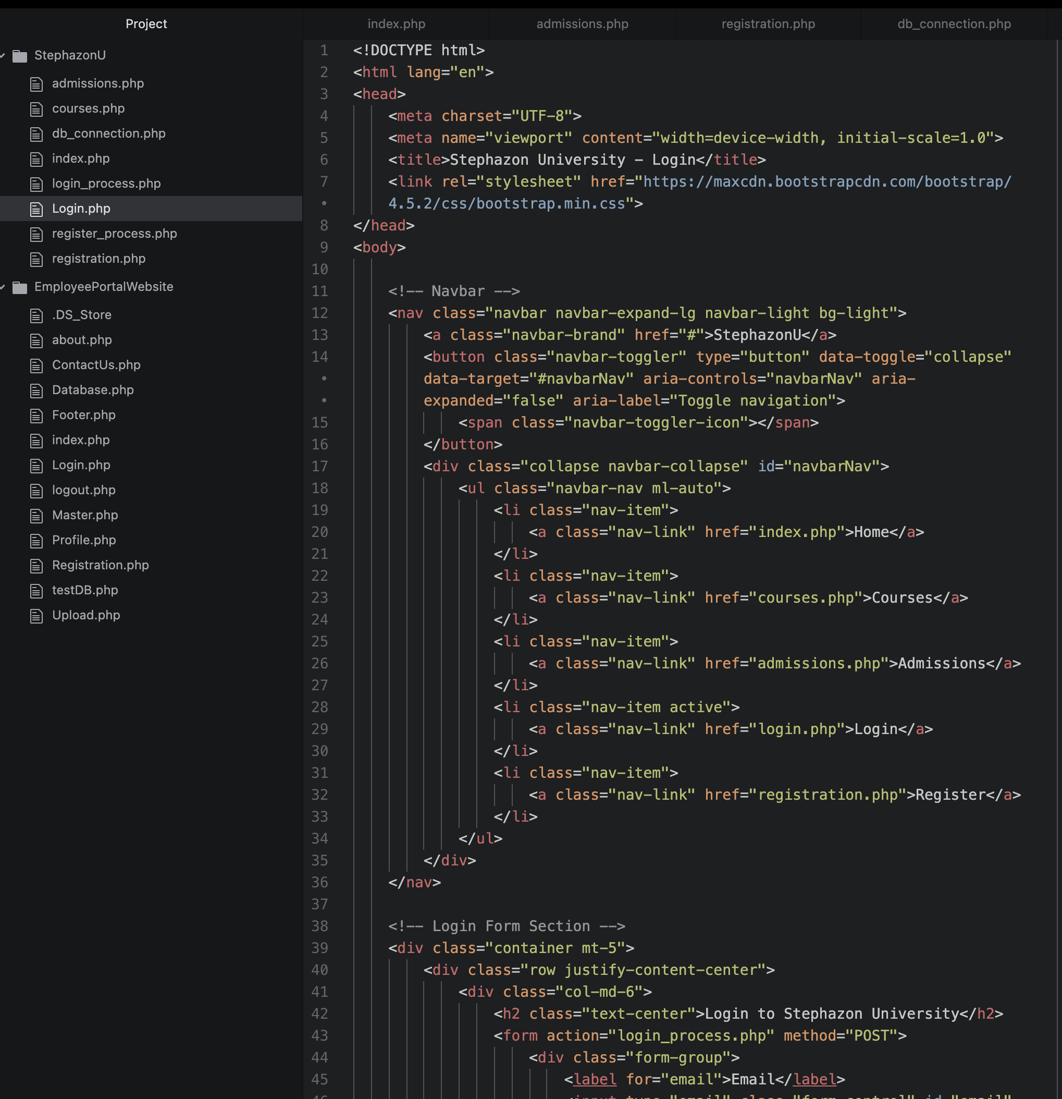

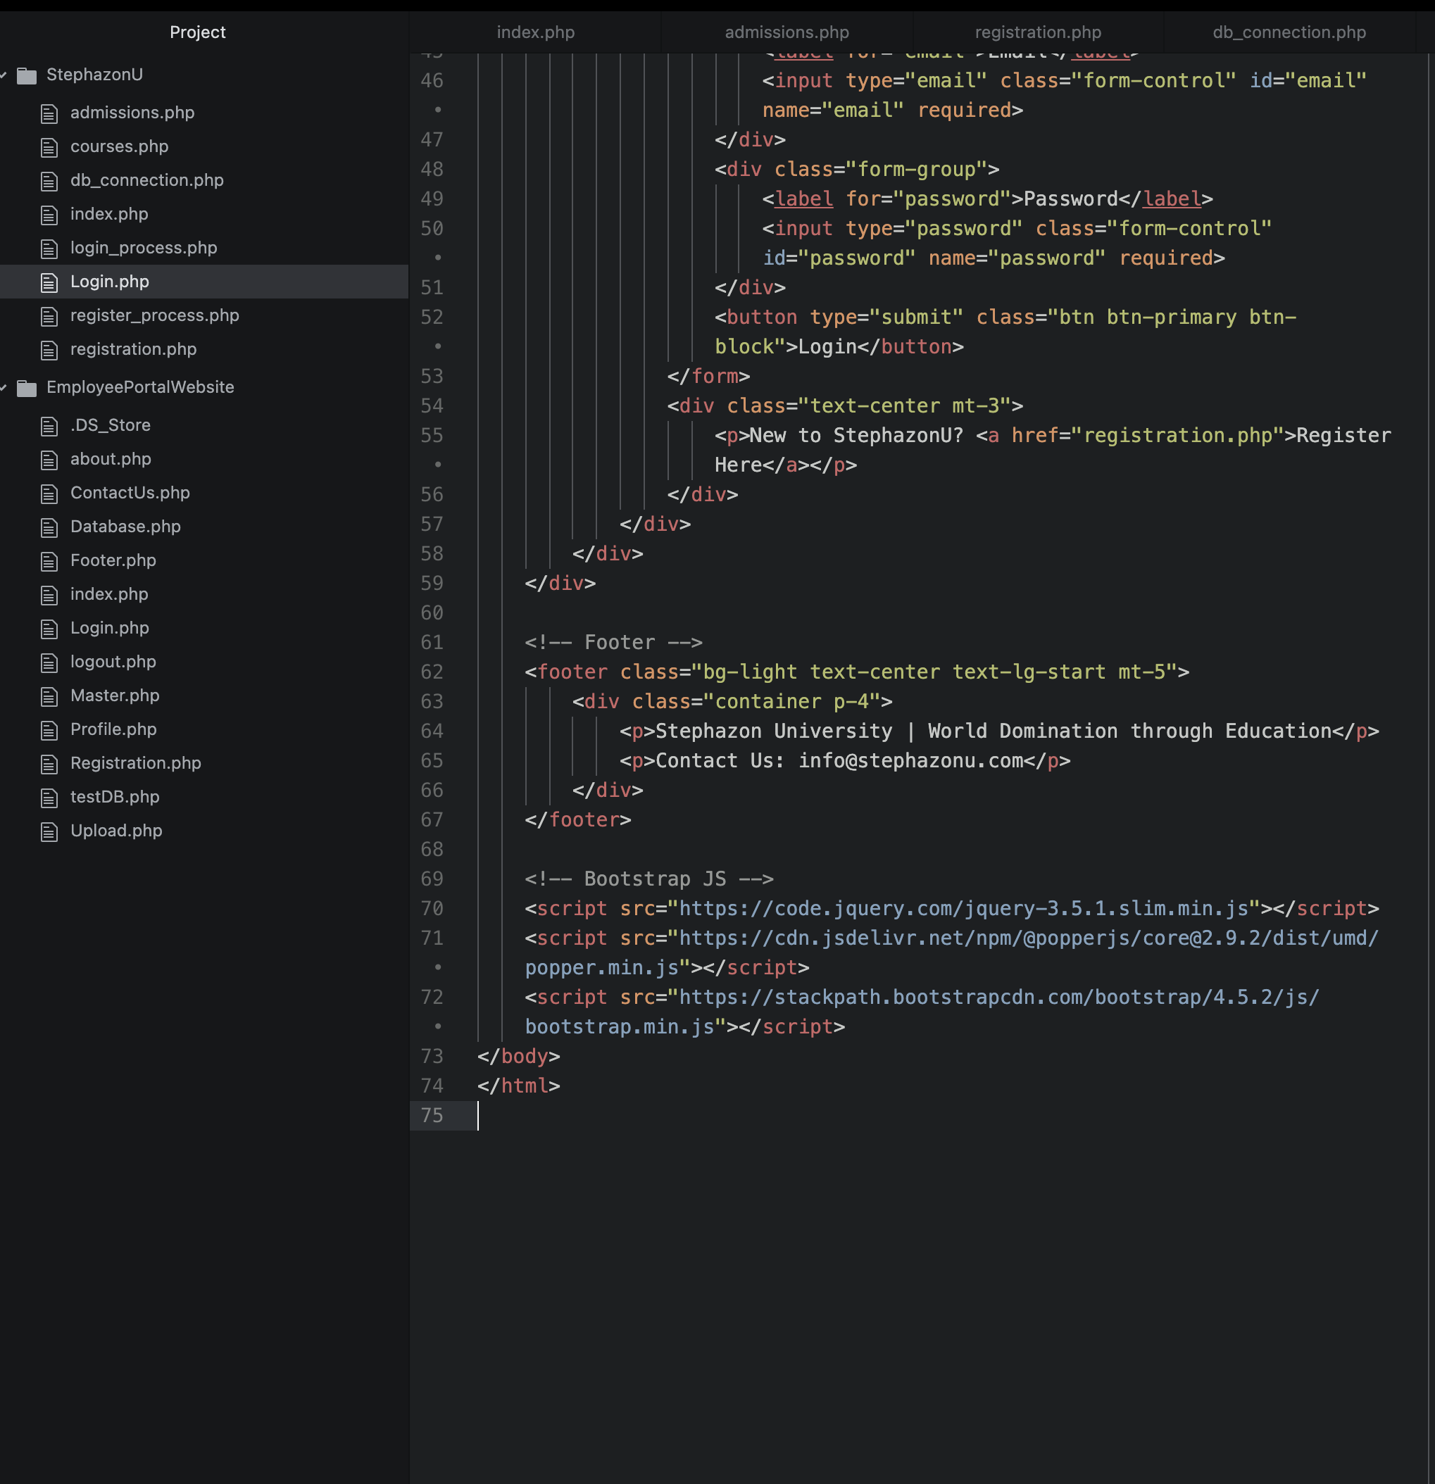

**Login_process.php**

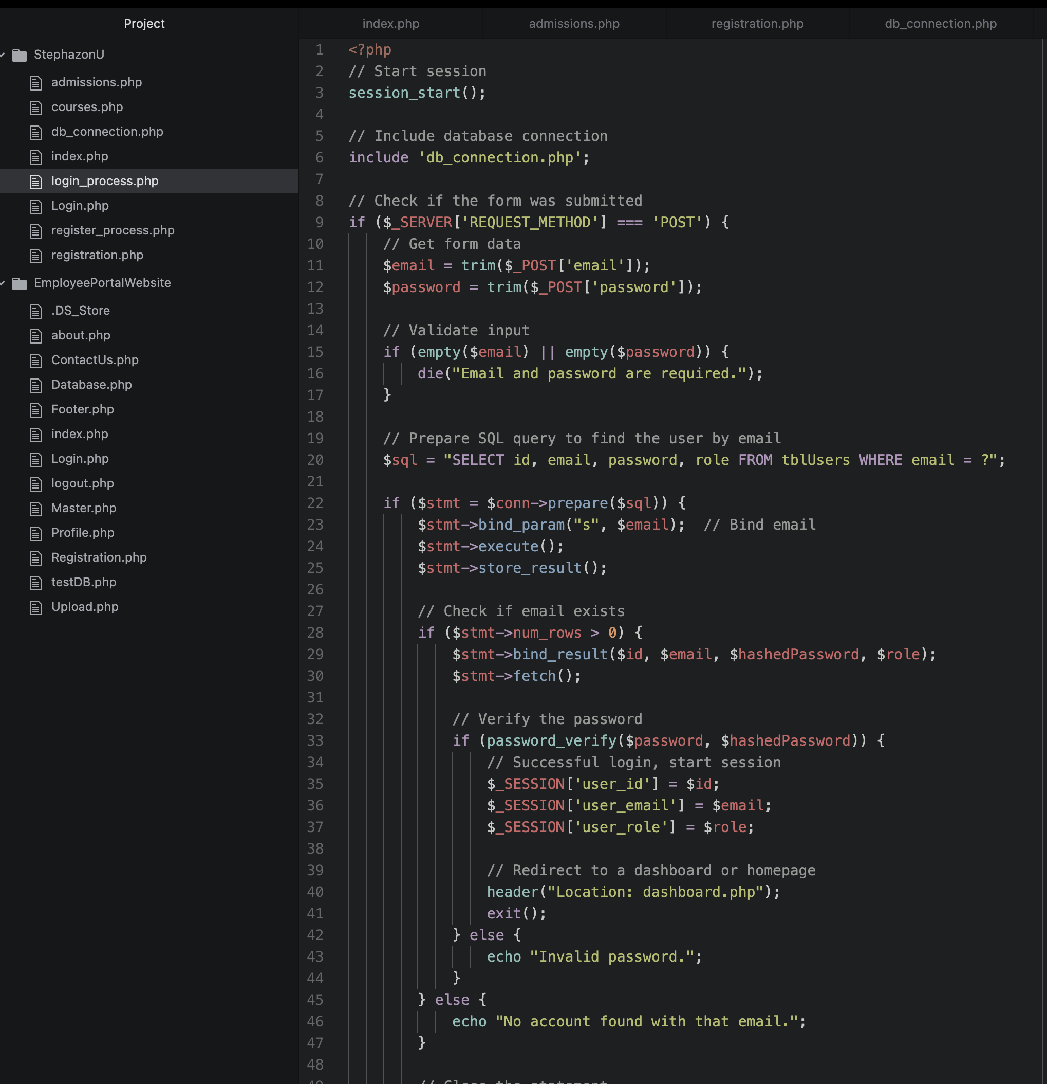

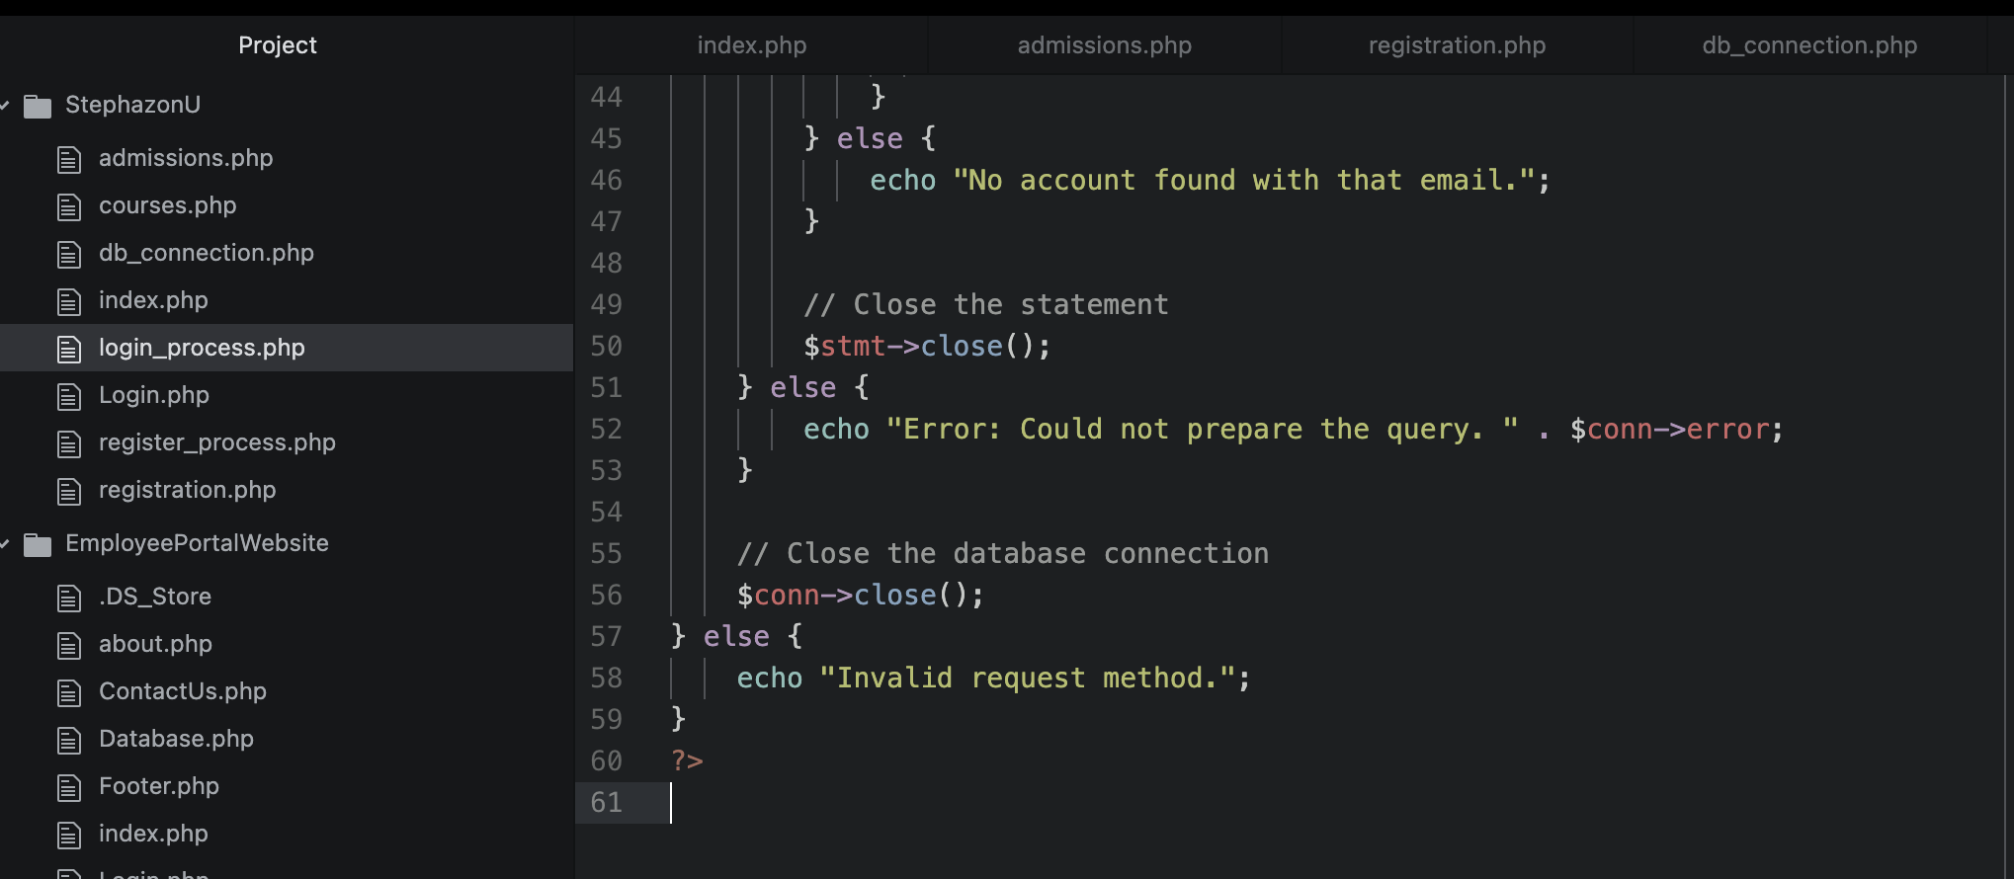

**References:**

Oracle. (2022). *Using prepared statements*. The JavaTM Tutorials. https://docs.oracle.com/javase/tutorial/jdbc/basics/prepared.html

Ravikiran, A. S. (2024, August 13). *How to run a PHP using XAMPP: Simplilearn*. Simplilearn.com. https://www.simplilearn.com/tutorials/php-tutorial/php-using-xampp

Tsui, F., Karam, O., & Bernal, B. (2018). [*Essentials of software engineering*](https://uagc.instructure.com/courses/137118/modules/items/6984922)(4th ed.). Jones & Bartlett Learning.

Connolly, R., & Hoar, R. (2022). [*Fundamentals of web development*](https://uagc.instructure.com/courses/137118/modules/items/6984922) (3rd ed.). Pearson.